REST ASSURED EMP ID :2587303

NAME: R.HIMABINDU

1. Write a program to set up or configure REST assured.

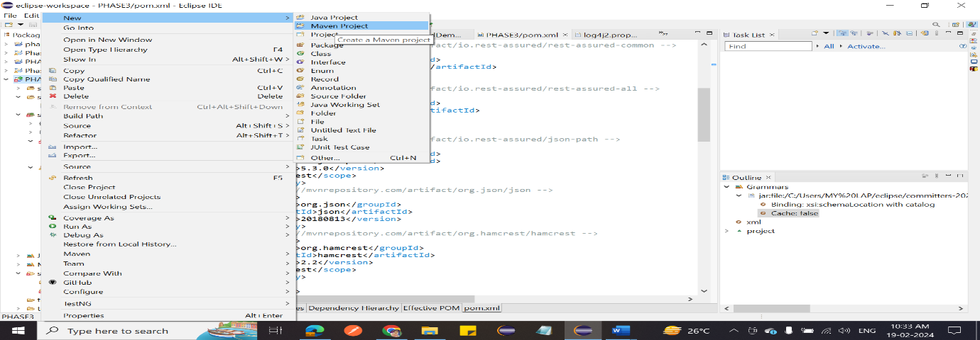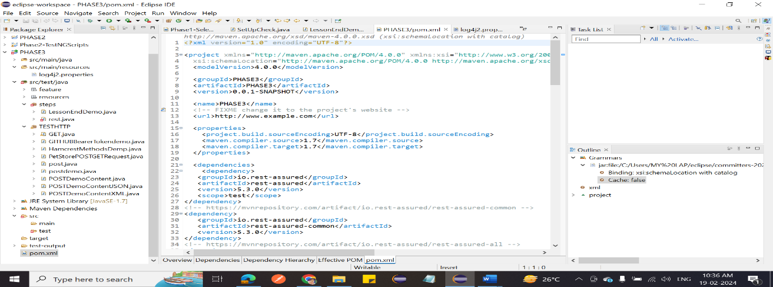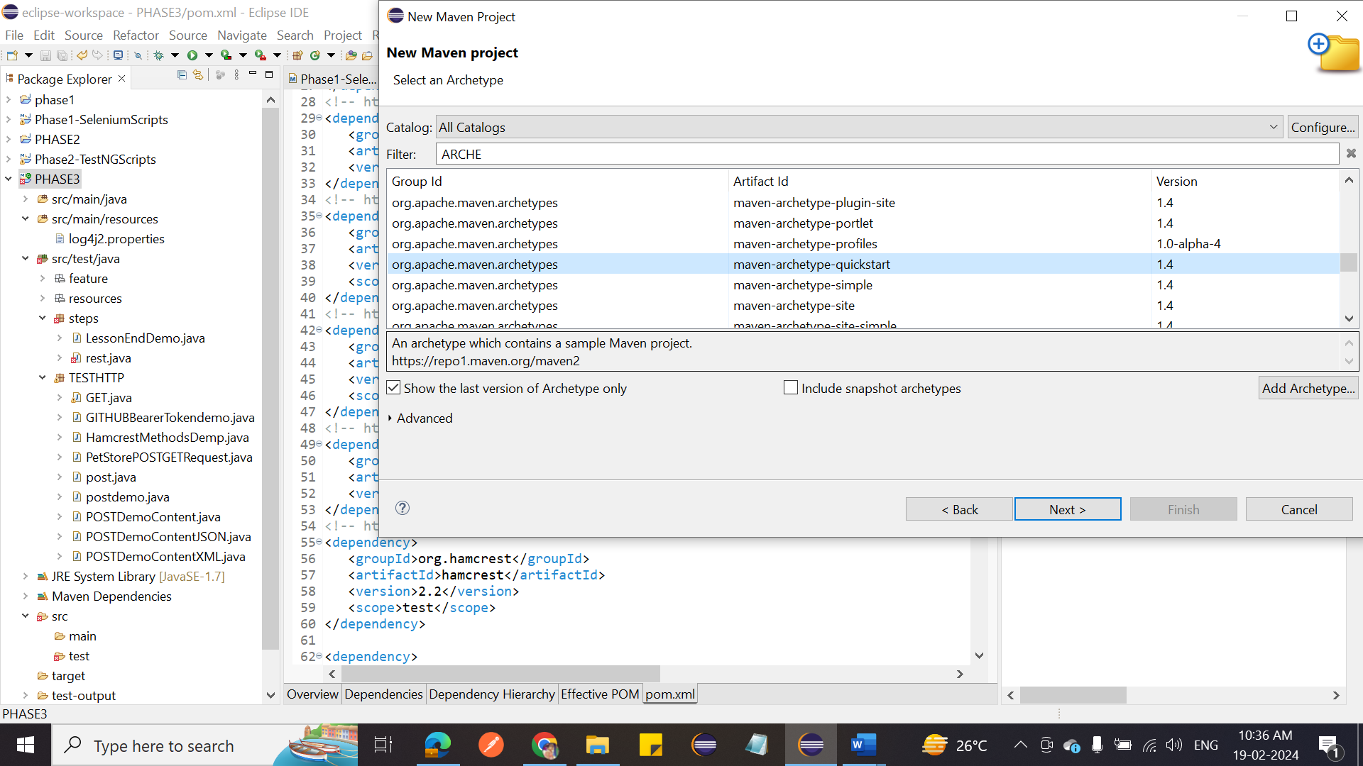

1. Write a program to demonstrate automation of GET request and response.

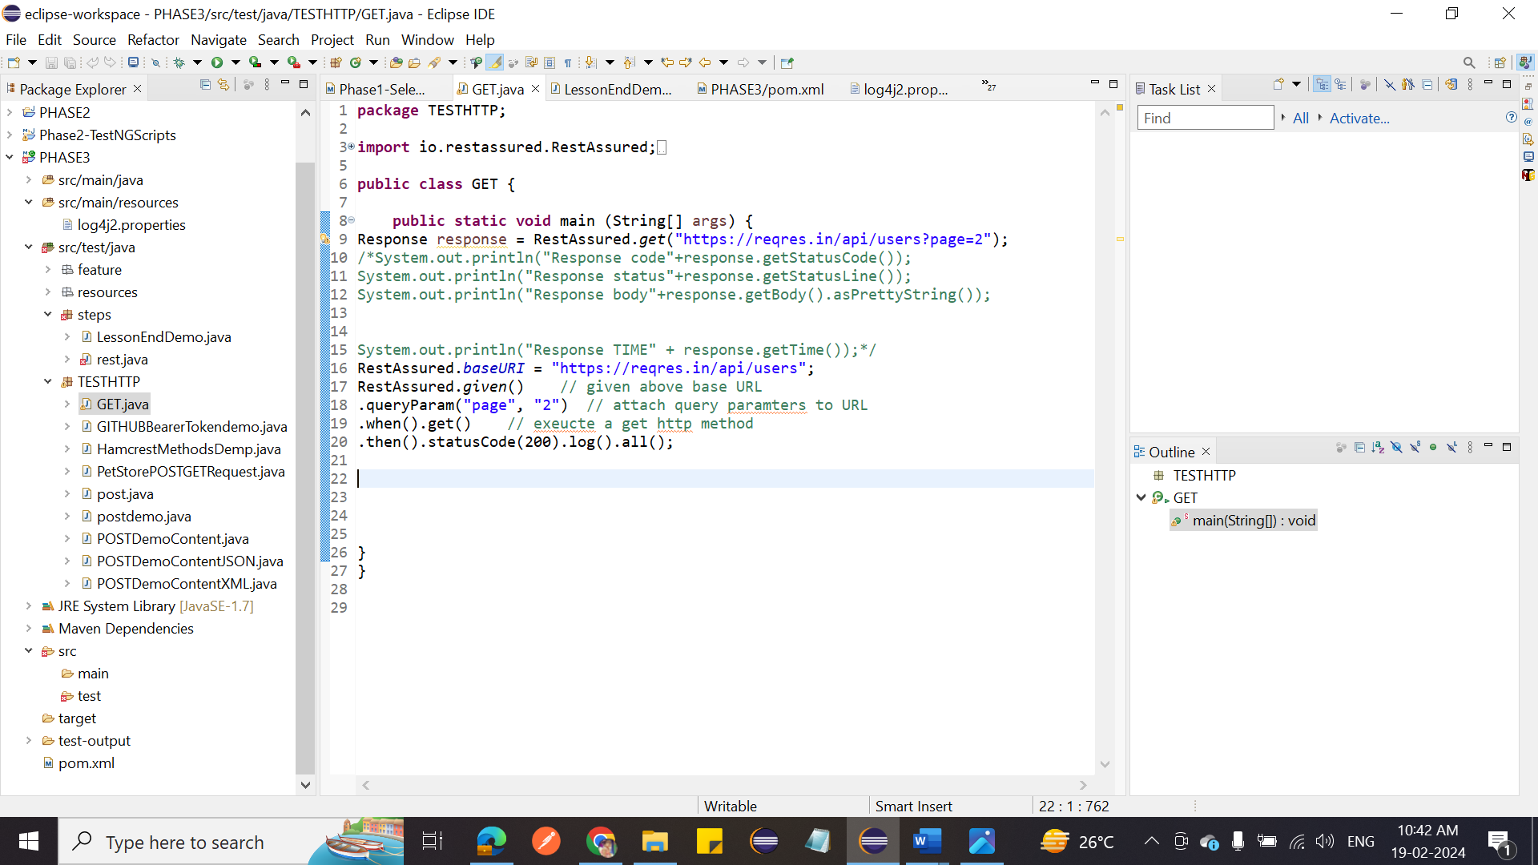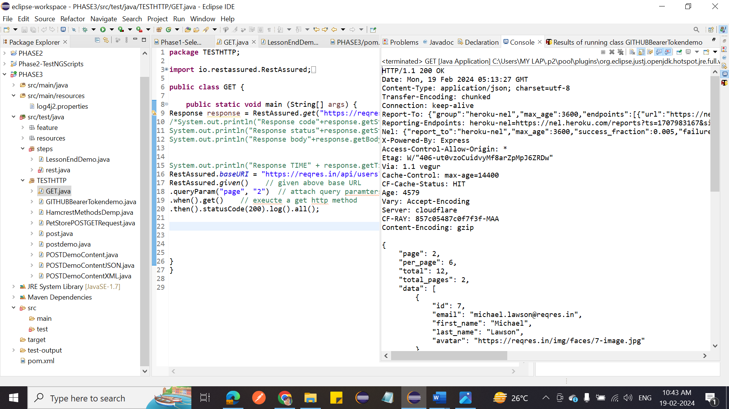

1. Write a program to demonstrate automation of POST request and response.

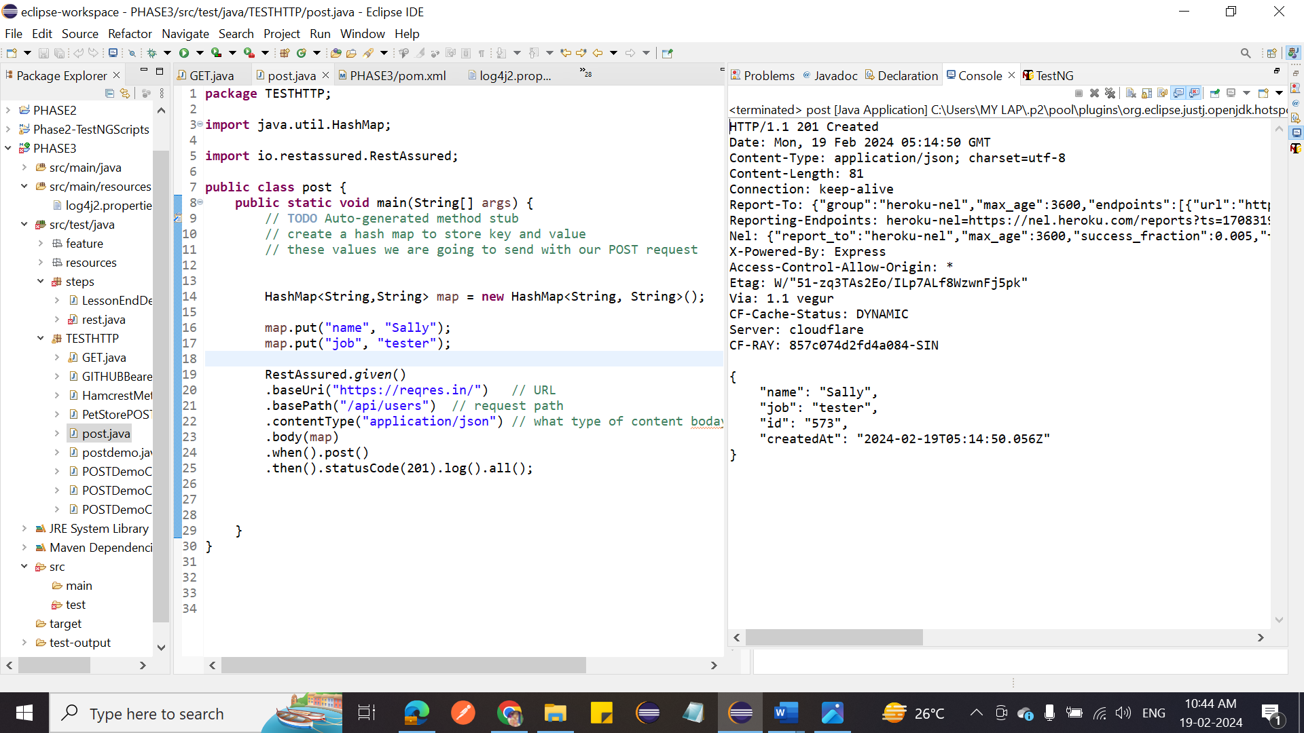

1. Write a program to send XML payload in REST assured, parse XML response in REST assured, parse JSON response in REST assured, and explore native logging of REST assured.

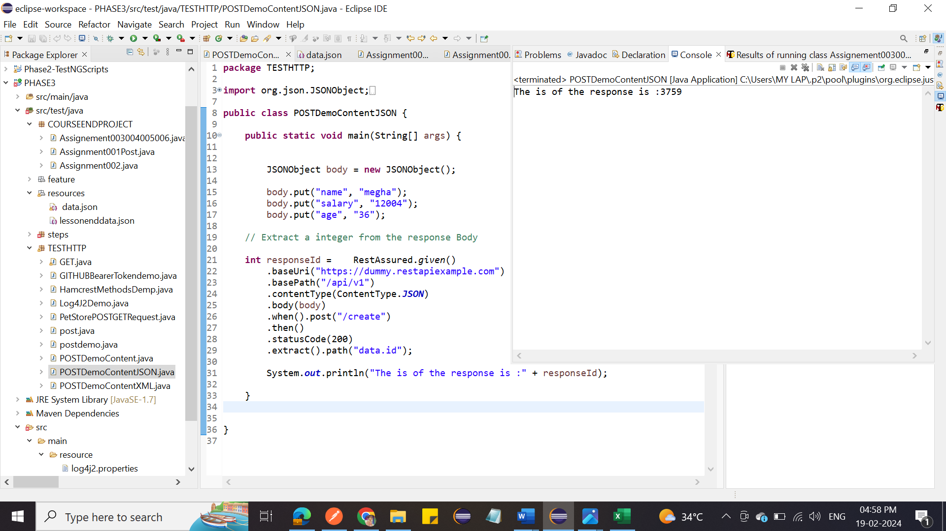

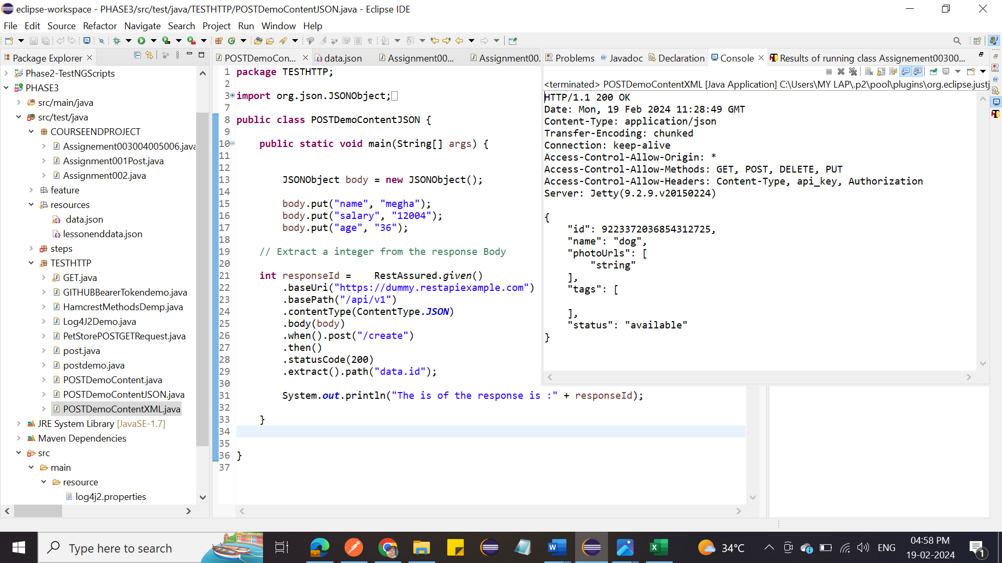

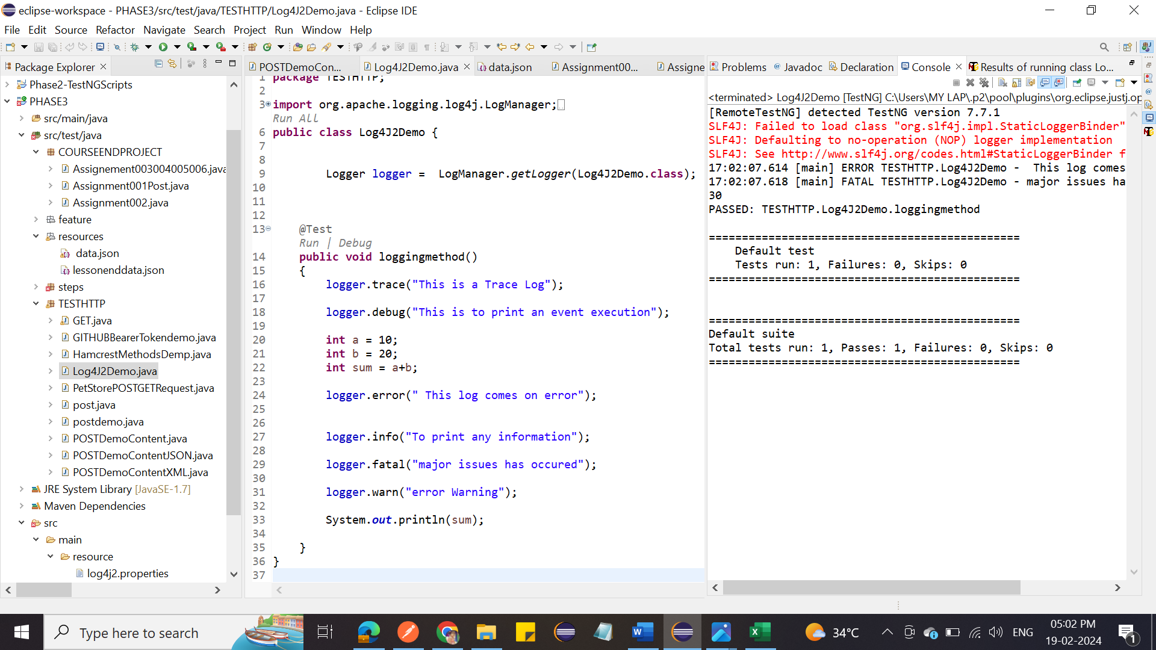

1. Write a program to demonstrate GET, POST, XML, and JSON in REST Assured.



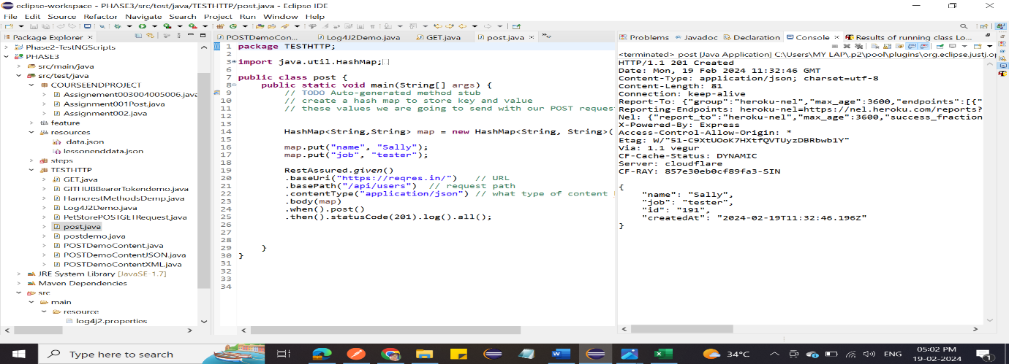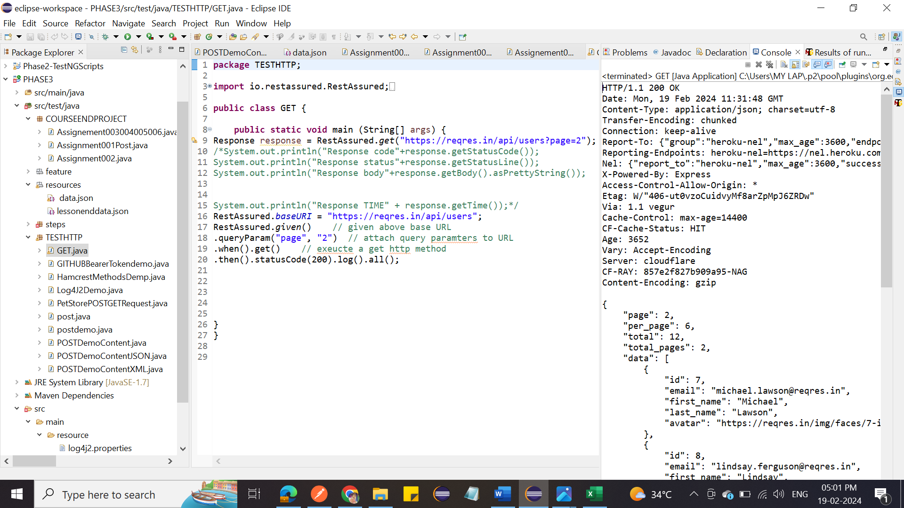

1. Write a program to demonstrate OAuth authorization in REST API using REST assured.

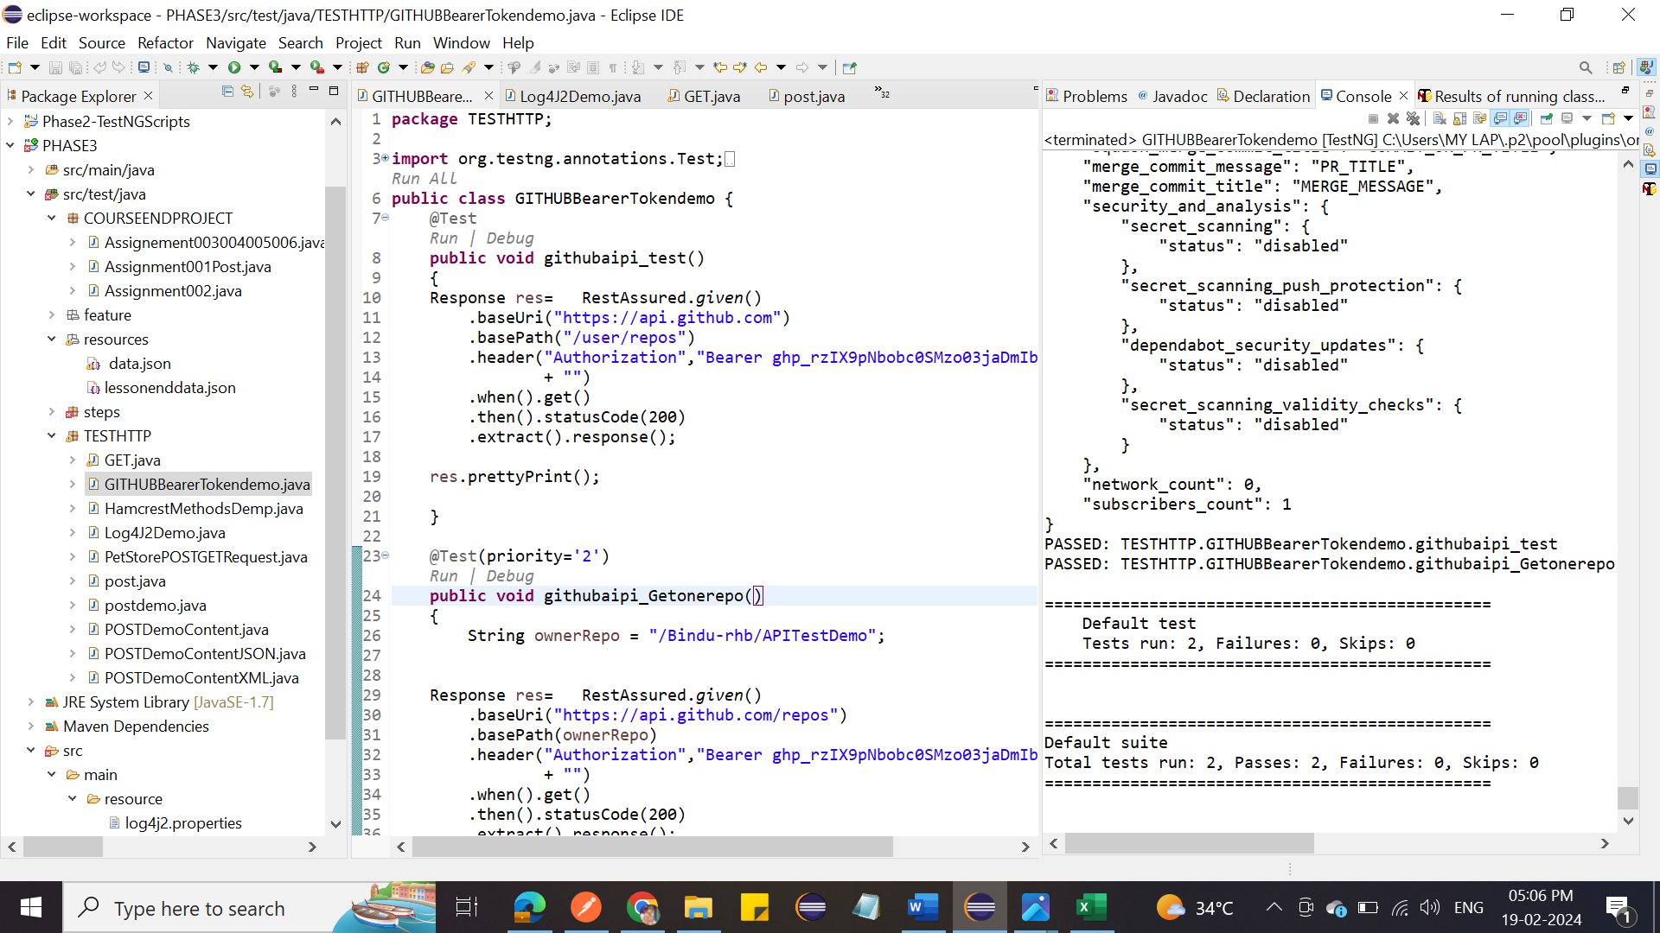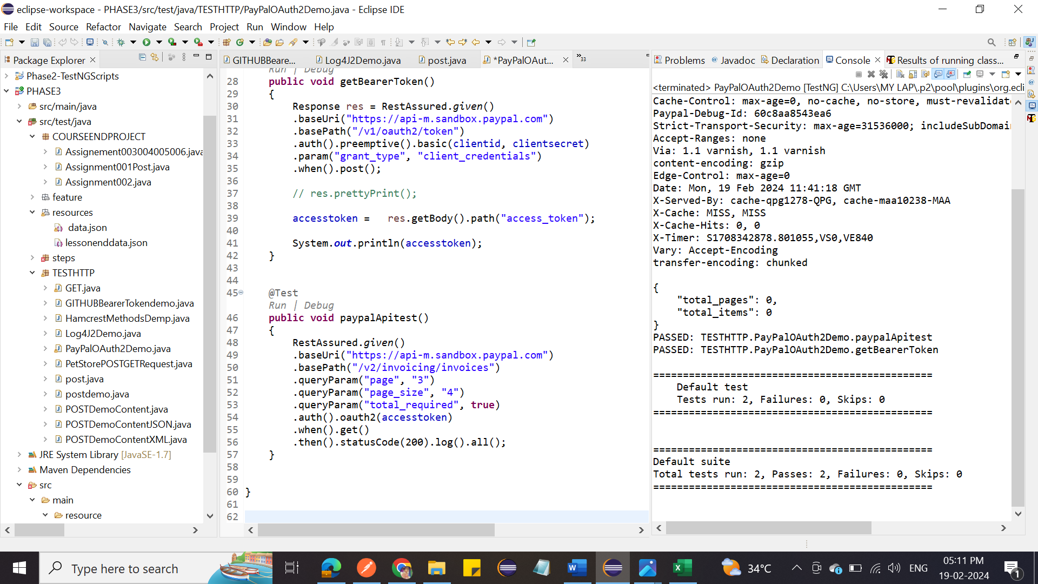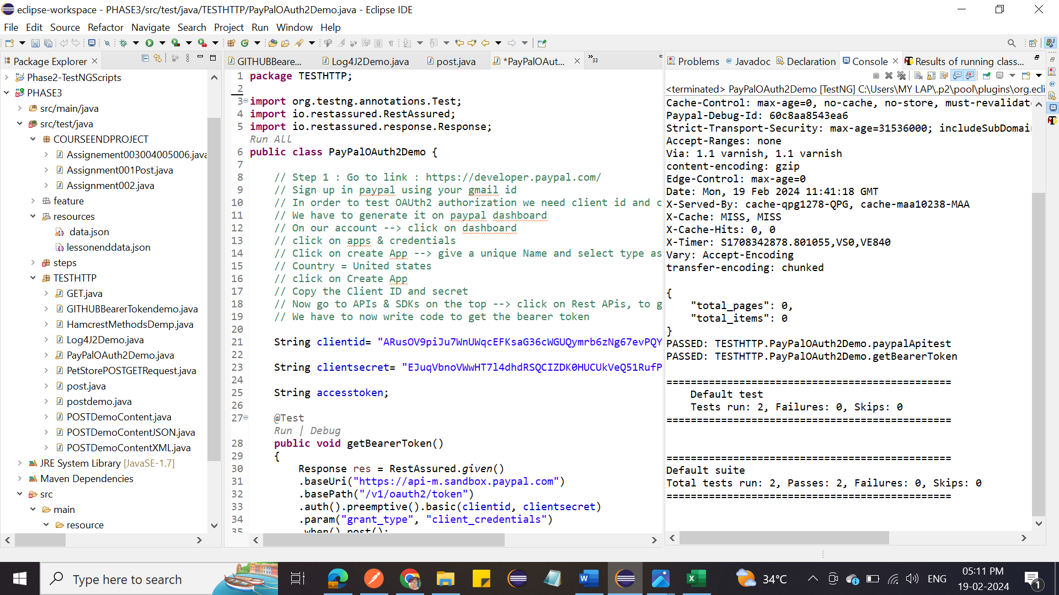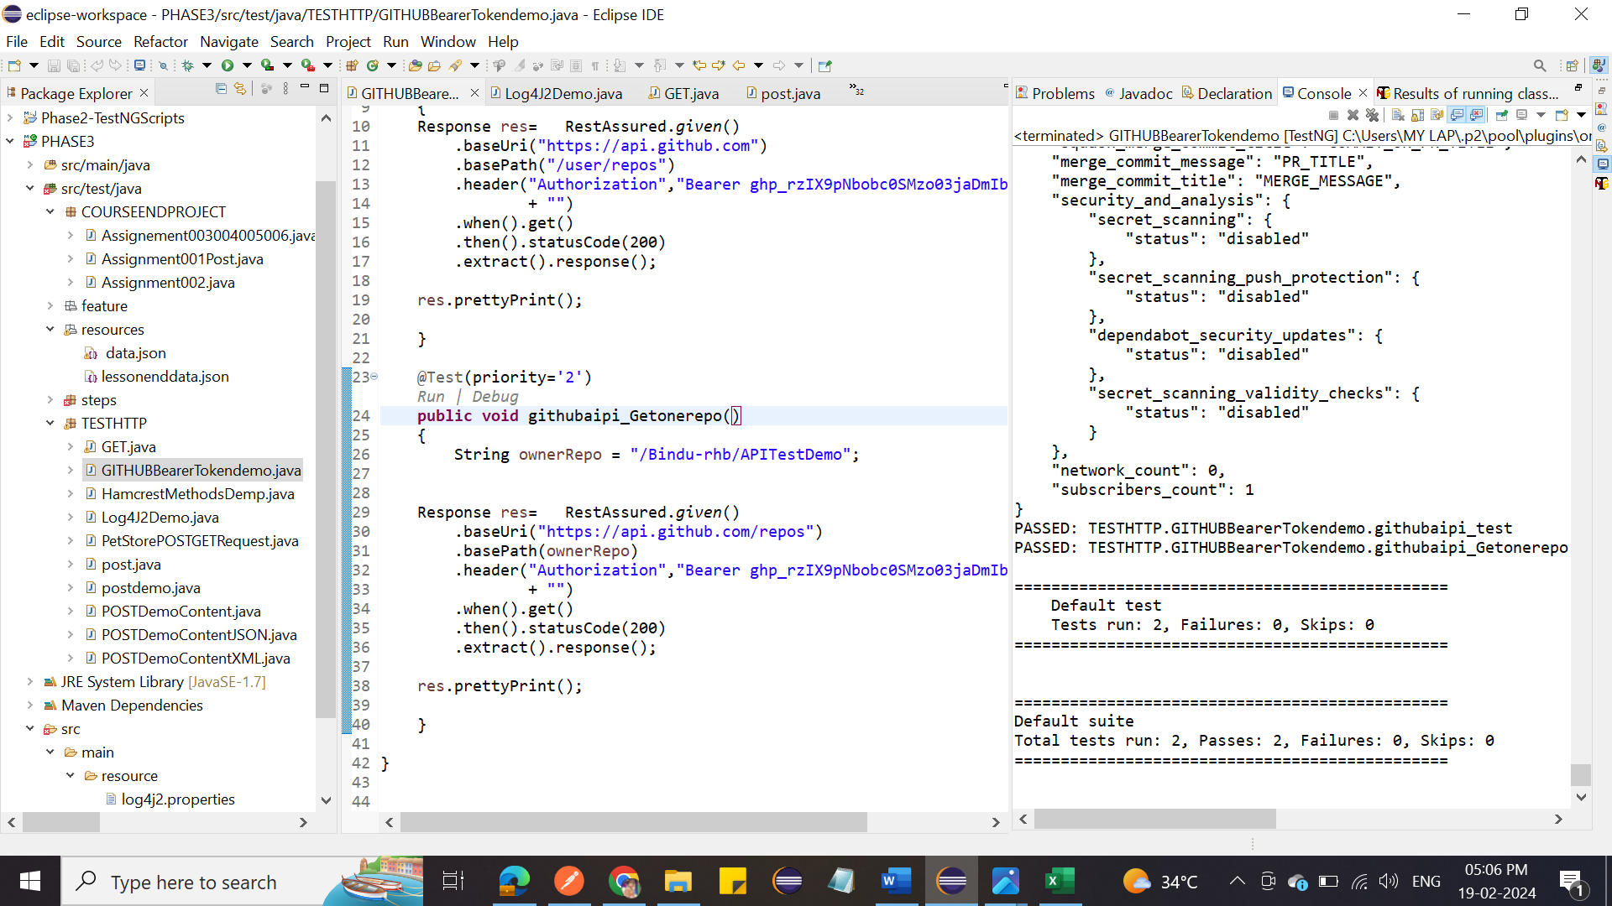

1. Write a program to demonstrate SSL authentication.
2. Write a program to configure Log4j in Eclipse Maven project.

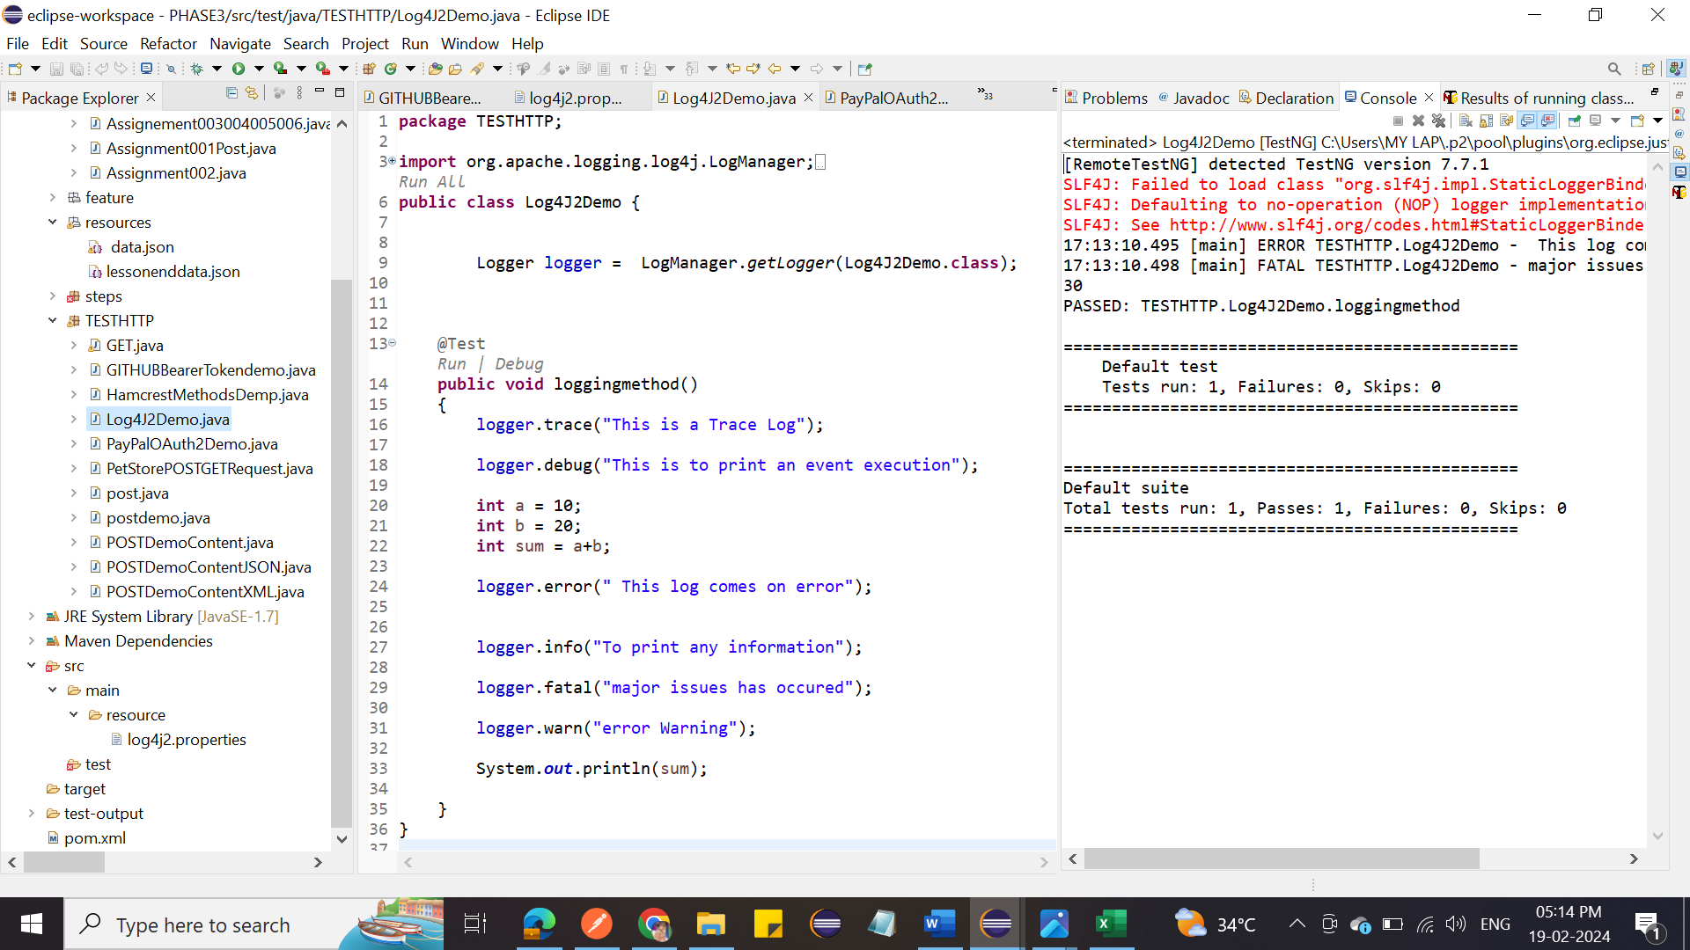

1. Write a program to generate logs on Eclipse Console using Log4j.

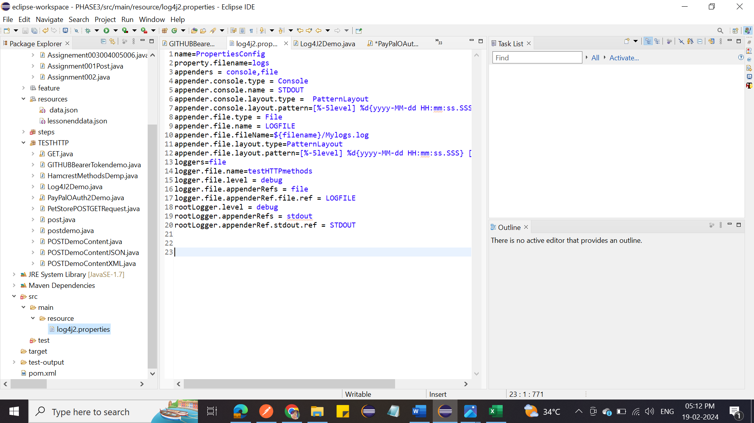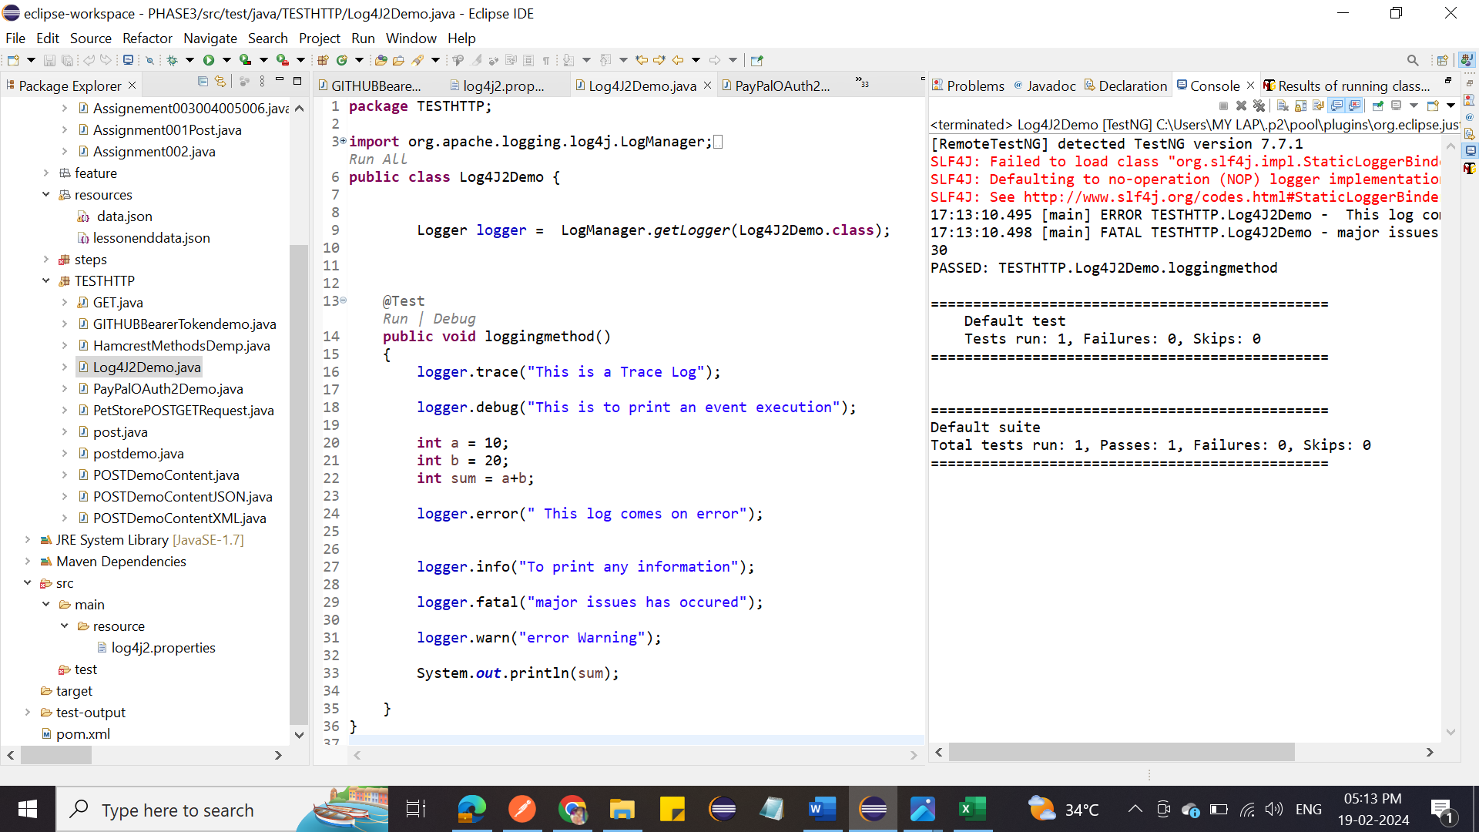

1. Write a program to write log file using Log4j.



1. Write a program to demonstrate OAuth, SSL, and Log4j.



1. Write a program to implement BDD with REST assured using Cucumber. 